1. Write a shell script that determines the period for which a specified user is working on the system. 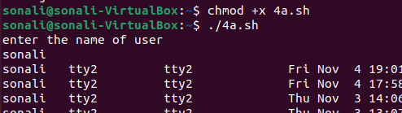

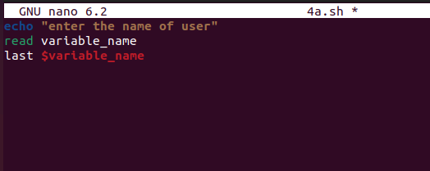

1. Write a shell script that displays all the lines between start and end line numbers passed as argument. 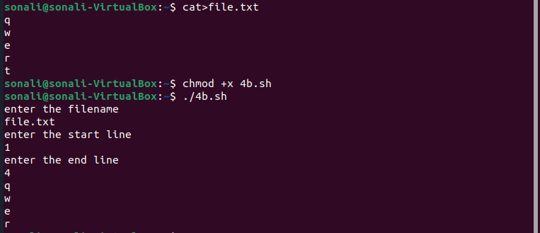

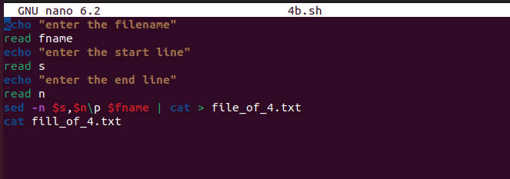

1. Write a shell script that deletes all lines containing a specified word in one or more files supplied as arguments to it.



